DATA: / / 2020

PROFESSOR (A) ANA PATRICIA VIEIRA
ATIVIDADE DE REDAÇÃO

SÉRIE: 5º ANO
ALUNO (A): Nº:

TURMA: B
NOTA:

1º BIMESTRE

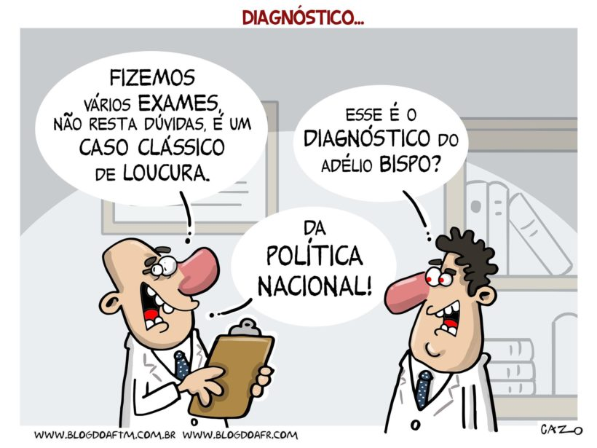

De acordo com o tema discutido durante a aula, reúna as informãções levantadas, em seguida produza um texto dissertativo sobre como você acredita que esteja o atual cenário da Política no Brasil, quais nossos principais problemas, e como você acredita que podemos melhorar esse cenário.

_______________________________________________
____________________________________________________________________________________________________________________________________________________________________________________________________________________________________________________________________________________________________________________________________________________________________________________________________________________________________________________________________________________________________________________________________________________________________________________________________________________________________________________________________________________________________________________________________________________________________________________________________________________________________________________________________________________________________________________________________________________________________________________________________________________________________________________________________________________________________________________________________________________________________________________________________________________________________________________________________________________________________________________________________________________________________________________________________________________________________________________________________________________________________________________________________________________________________________________________________________________________________________________________________________________________________________________________________________________________________________

